Multiple-choice section

|  |  |  |  |  |  |  |  |  |
| --- | --- | --- | --- | --- | --- | --- | --- | --- |
| Question | 1 | 2 | 3 | 4 | 5 | 6 | 7 | 8 |
| Answer | A | C | A | C | B | D | C | B |

Question 1 [4.6] [10A]

A

ax2 +bx + c = x2 – 2x + 5

a = 1, b = -2, c = 5

Question 2 [4.5] [10A]

C

6x2 – x – 15

= 6x2 – 10x + 9x – 15

= 2x(3x − 5) + 3(3x − 5)

= (2x + 3)(3x – 5)

Question 3 [4.6] [10A]

A

x = 2 and x = -5

(x – 3) and (x + 5) are factors

(x – 2)(x + 5) = 0

Question 4 [4.6]

C

(x – 7)(x + 3) = 0

As each factor can be equated to 0, the null factor law is the quickest way to solve this equation.

Question 5 [4.2]

B

x2 + 6x + 2

= x2 + 6x +  –  + 2

= x2 + 6x + 9 – 9 + 2

= (x + 3)2 – 7

= (x + 3 +  )(x + 3 – )

Question 6 [4.4]

D

y = x2 + 2x – 8

y = 02 + 20 – 8

y = - 8

Question 7 [4.1]

C

Use the null factor law.

x = 0, -7

Question 8 [4.4]

B

y = (x − 12)2 + 5

The turning point is (12, 5).

Multiple-choice total marks: 8

Short answer section

Question 9 9 marks [4.1, 4.3]

(a) x(x + 2) = 0

x = 0 or x + 2 = 0

x = 0 or -2

(b) (x + 3)(x – 2) = 0

x + 3 = 0 or x – 2 = 0

x = -3 or x = 2

(c) 4x2 – 9 = 0

(2x – 3)(2x + 3) = 0

2x – 3 = 0 or 2x + 3 = 0

x = 

(d) x2 + 6x + 7 = 0  
x2 + 6x +  –  + 7 = 0x2 + 6x + 9 – 9 + 7 = 0(x + 3)2 – 2 = 0  
(x + 3)2 –  = 0(x + 3 + )(x + 3 − ) = 0  
(x + 3 + ) = 0 or (x + 3 − ) = 0  
x = -3 –  or x = -3 +   
x = -3 

Question 10 4 marks [4.1]

(a)  and 



(b) (x + 1)(x + 6) = 0

x + 1 = 0 or x + 6 = 0

x = -1 or x = -6

Question 11 6 marks [4.1]

|  |  |
| --- | --- |
| (a) x2 + 5x − 14 = (x + 7)(x − 2)  (b) Dimensions = x + 7 or x – 2 x + 7 = 13 x = 6 x − 2 = 4  Length = 13 cm, width = 4 cm x − 2 =13 x = 15  15 + 7 = 22  Length = 22 cm, width = 13 cm | (c) Area = *LW*  For x = 6  Area = 13 × 4  = 52 cm2  For x = 15  Area = 22 × 13  = 286 cm2 |

Question 12 3 marks [4.2]



Question 13 5 marks [4.2, 4.3, 4.4]

(a) x2 + 4x – 5 = x2 + 4x + 4 – 4 – 5

= (x2 + 4x + 4) – 9

= (x + 2)2 – 9

(b) (-2, -9)

(c) x-intercepts where y = 0:

(x + 2)2 – 9 = 0

(x + 2 – 3)(x + 2 + 3) = 0

(x – 1)(x + 5) = 0

x = 1 or -5

x-intercepts: (1, 0) and (-5, 0)

Question 14 4 marks [4.6] [10A]

(a) x2 + x + 7 = 0

x = 

= 

As ** has no real value, there are no real solutions.

(b) 2x2 – 5x – 12 = 0

x = 

= 

As **can be evaluated, there are real solutions.

Question 15 3 marks [4.6] [10A]

2y2 − 10y + 3y – 15 = 0

Find factors of -30 with a sum of -7. Use -10 and 3:

2y2 − 10y + 3y – 15 = 0

2y(y − 5) + 3(y – 5) =0

(y – 5)(2y + 3) = 0

y = 5, y = -

Question 16 3 marks [4.4]

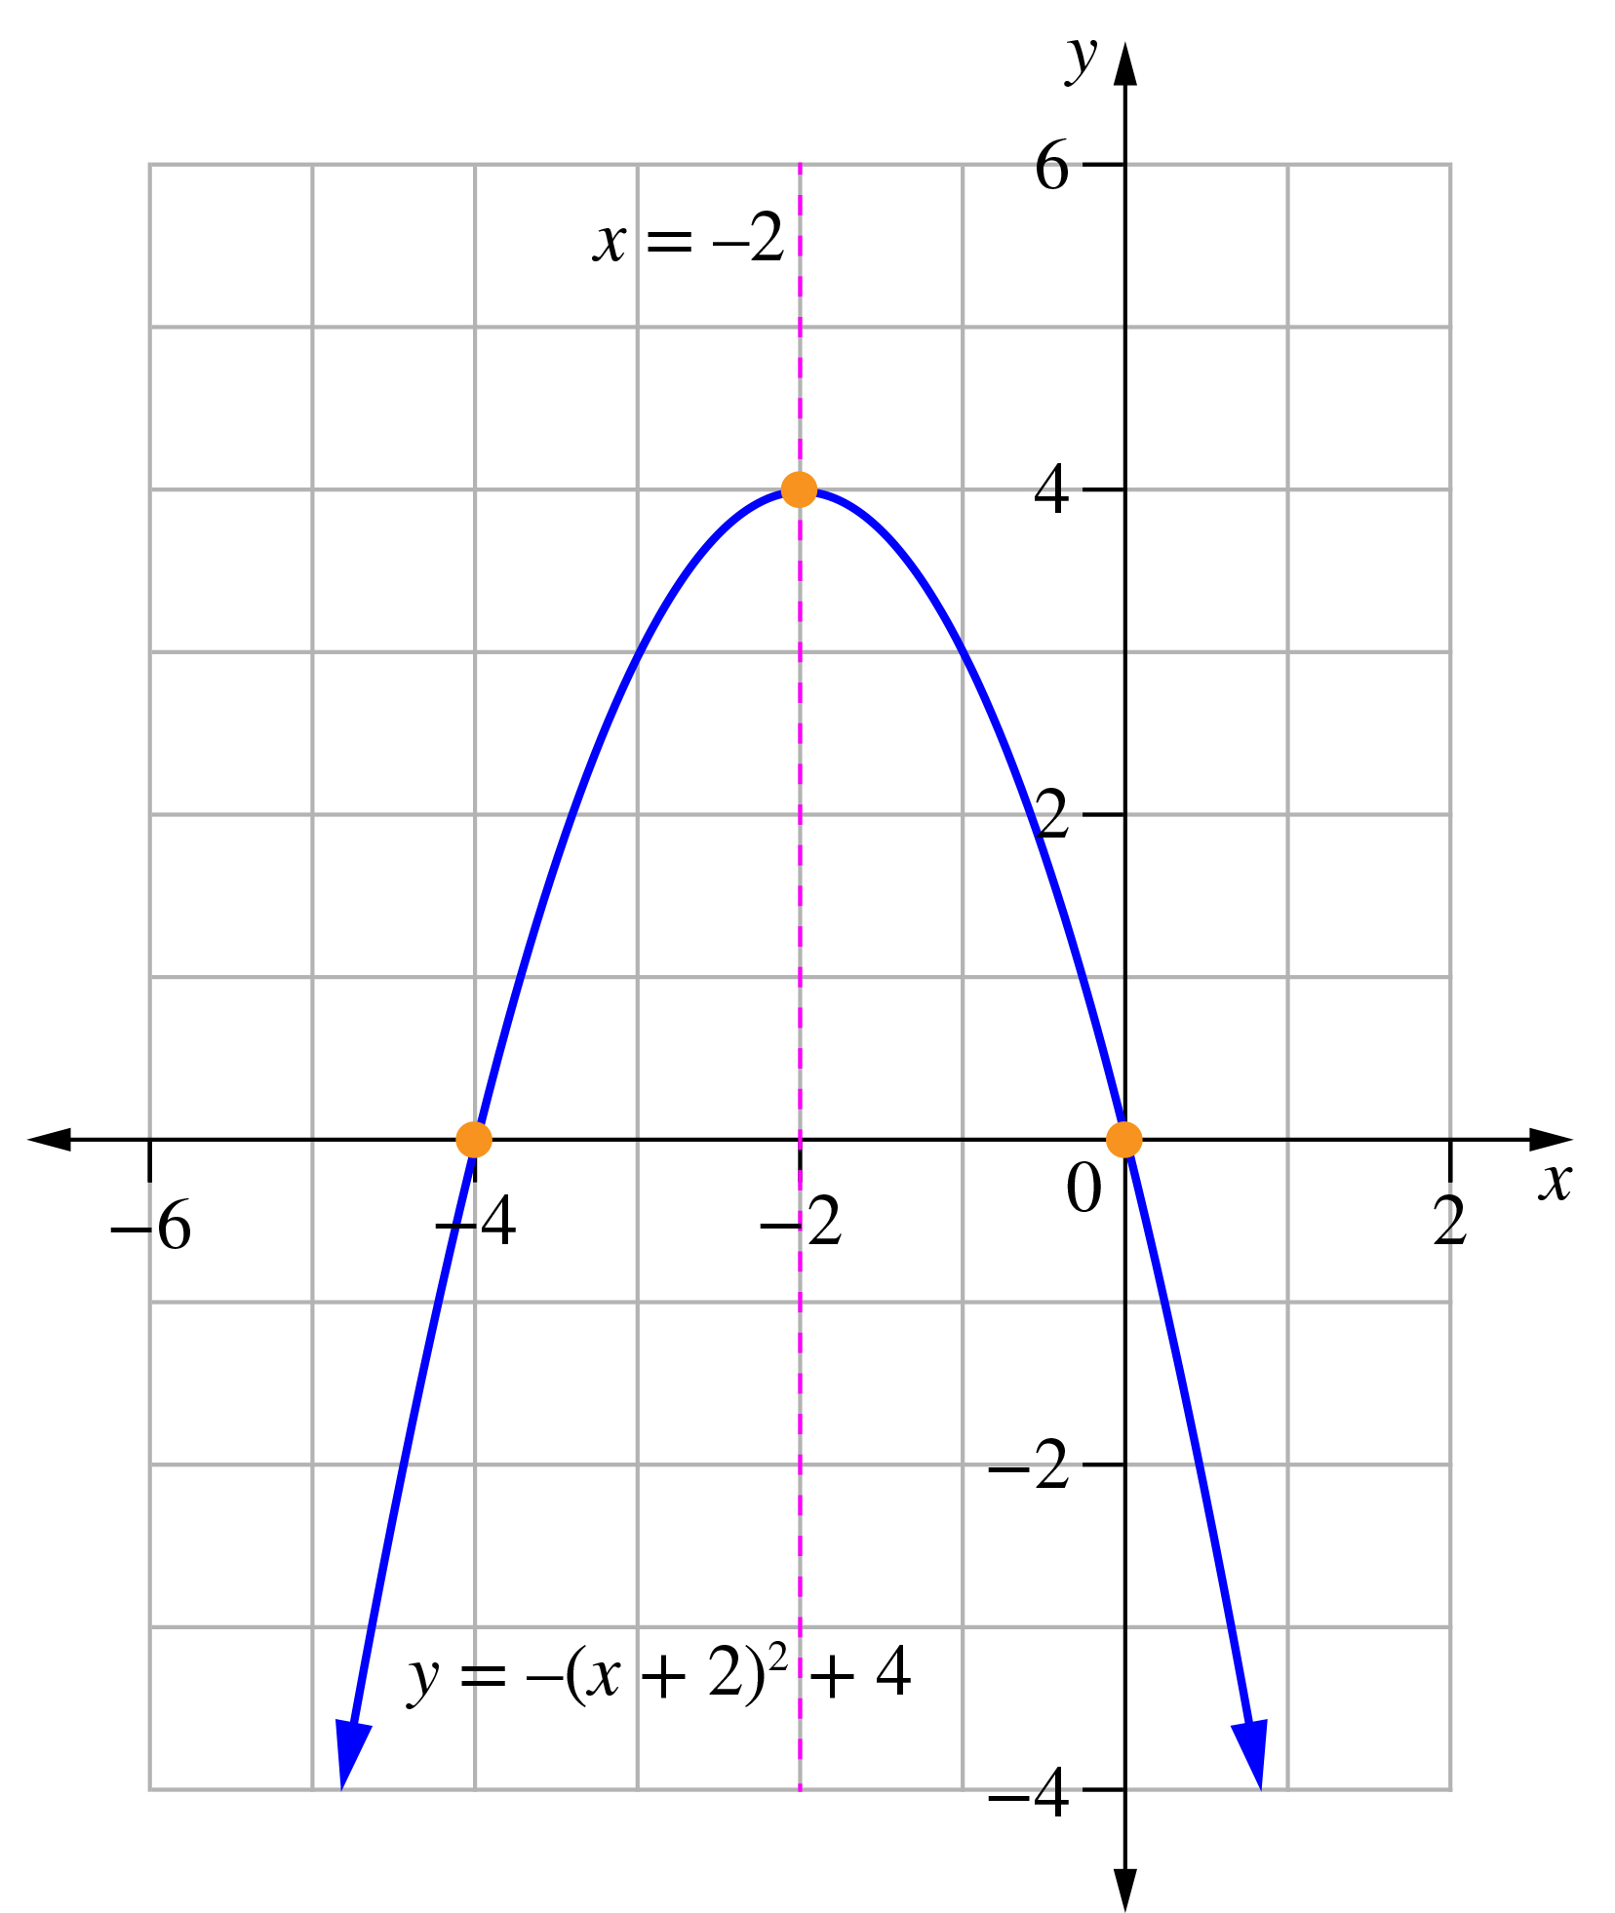

Question 17 3 marks [4.4]

Turning point is at (h, k) = (4, 6) so 

Where x = 6, 26 = a(6 – 4)2 + 6

26 = 4a + 6

5 = a

Short answer total marks: 40

Extended answer section

Question 18 6 marks [4.2, 4.3, 4.4]

|  |  |
| --- | --- |
| (a)  C:\Users\uCarrTi\Documents\CURRENTish\PM v2\PRODUCTION tracking etc\ASSETS various for eBooks\Chapter tests exams\y10 lastmin images\PM2e_10_EB_04_FAA_01.jpg  (b) Maximum height at turning point (20, 800). So maximum height = 800 m. | (c) Where y = 0:  -2(d – 20)2 + 800 = 0  (d – 20)2 – 400 = 0  (d – 20 + 20)(d – 20 − 20) = 0  d(d – 40) = 0  d = 0 or 40  Distance to target is 40 km. |

Question 19 9 marks [4.4]

(a)

|  |  |  |  |  |  |  |  |
| --- | --- | --- | --- | --- | --- | --- | --- |
| x | 0 | 1 | 2 | 3 | 4 | 5 | 6 |
| y | 0 | 5 | 8 | 9 | 8 | 5 | 0 |

(b)

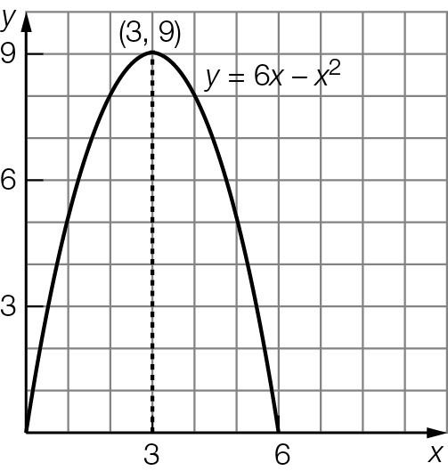

(c) (3, 9)

(d) x-intercepts are (0, 0) and (6, 0); y-intercept is (0, 0).

(e) 6x – x2 = 5  
x2 – 6x + 5 = 0   
(x – 5)(x – 1)= 0   
x = 1, 5

The ball was at a height of 5 m, 1 seconds and 5 seconds after the ball was thrown.

(f) There are two times, when the ball was on the way up and when the ball was on the way down.

(g) The ball reaches a maximum height of 9 m. It does not reach the 10 m level.

Extended answer total marks: 15

TOTAL test marks: 63